LC#48:ROTATE IMAGE
APP1:BRUTE O(N^2)
- From this we infer that from if 1st row element is in last row
- Matrix[j][n-1-i] = res[i][j]
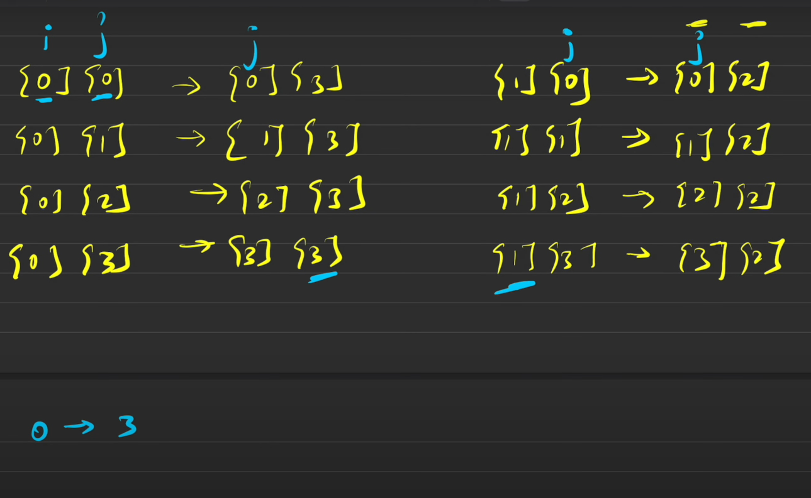
class Solution {
public void rotate(int[][] matrix) {
int n = matrix.length;
int res[][] = new int[n][n];
for(int i = 0 ; i < n ; i++)
for(int j=0 ; j< n ; j++)
res[j][n-1-i] = matrix[i][j];
for(int i = 0 ; i< n; i++)
{
for(int j = 0 ;j < n ;j++)
{
matrix[i][j] = res[i][j];
}
}

}}
APPROACH 2:
->first transpose ( i = 0 , j = i+1) keep in mind
->then reverse the row elements(col shift)
class Solution {
public void rotate(int[][] m) {
int n = m.length;
for(int i = 0 ; i<n;i++)
{
for(int j = i+1; j <n;j++)//TRANSPOSE
{SWAPPING BASED ON XOR
m[i][j] = m[j][i]^m[i][j];
m[j][i] = m[j][i]^m[i][j];
m[i][j] = m[j][i]^m[i][j];
}
}
for(int i= 0 ;i<n;i++)
{ int left = 0 , right = m[i].length-1;
while(left<right)//BINARY SEARCH SWAP
{//perform normal swap xor for uniqueness
m[i][left] ^=m[i][right];
m[i][right] ^=m[i][left];
m[i][left] ^=m[i][right];
left++;
right--;
}
}
}
}
LC#189 : ROTATE ARRAY BY k places
Example 1:
Input: nums = [1,2,3,4,5,6,7], k = 3
Output: [5,6,7,1,2,3,4]
Explanation:
rotate 1 steps to the right: [7,1,2,3,4,5,6]
rotate 2 steps to the right: [6,7,1,2,3,4,5]
rotate 3 steps to the right: [5,6,7,1,2,3,4]

APP1 : USING THREE LOOPS SEP AND AN ARRAY
class Solution {
public void rotate(int[] nums, int k) {
int n = nums.length;
int[] a = new int[n];
k = k % n;
int j = 0;
for (int i = n - k; i < n; i++)
a[j++] = nums[i];//after k elements
for (int i = 0; i < n - k; i++)
a[j++] = nums[i];//stores the remaining from start
for (int i = 0; i < n; i++)
nums[i] = a[i];//copying back
}
}

APP2:USING MODULUS AND AN EXTRA ARRAY
class Solution {
public void rotate(int[] nums, int k) {
int n = nums.length;
k = k % n;
int[] temp = new int[n];
for (int i = 0; i < n; i++) {
temp[(i + k) % n] = nums[i];//gets the element correctly (i+k)%n
}
for (int i = 0; i < n; i++) {
nums[i] = temp[i];
}
}
}

APP3: OPTIMAL
- Reverse the array
- Reverse first k in the reversed array
- Reverse the remaning elements from k to n
class Solution {
public void rotate(int[] nums, int k) {
int n = nums.length;
k = k%n;
if(k == 0)
return;
reverse(nums , 0 , n-1);//full reverse
reverse(nums , 0 , k-1);//reverse first k so until k-1 index
reverse(nums , k , n-1); //reverse remaining
}

public void reverse(int[] nums , int l , int r)
{
while(l<r)
{
int temp = nums[l];
nums[l] = nums[r];
nums[r] = temp;
l++;
r--;
}
}
}

